Name: Ali Sareini-6565 group c3
Project: Smart Greenhouse Monitoring and Control System
Course: Sensors and Instrumentation
Overview of Contribution:
My contribution to this project was spread across multiple areas rather than concentrated in a single component.
- Hardware Assembly: contributed to wiring portions of the circuit alongside teammates, assisting with sensor connections as part of the overall hardware build.
- Firmware Testing and Debugging: reviewed and made small modifications to sections of the Arduino code, and participated in testing the system to help identify issues during development.
- Report Writing: contributed to writing part of the technical report, including work on the Engineering Constraints Discussion (Section 10), covering cost, power, hardware, and reliability tradeoffs made during the project.
While my individual contributions in wiring and coding were smaller in scope compared to my repository and documentation work, I was consistently engaged across all phases of the project rather than specializing narrowly in one task.
I had some contribution in the video making and editing as well as my teammates.

2. Evidence of Work Performed
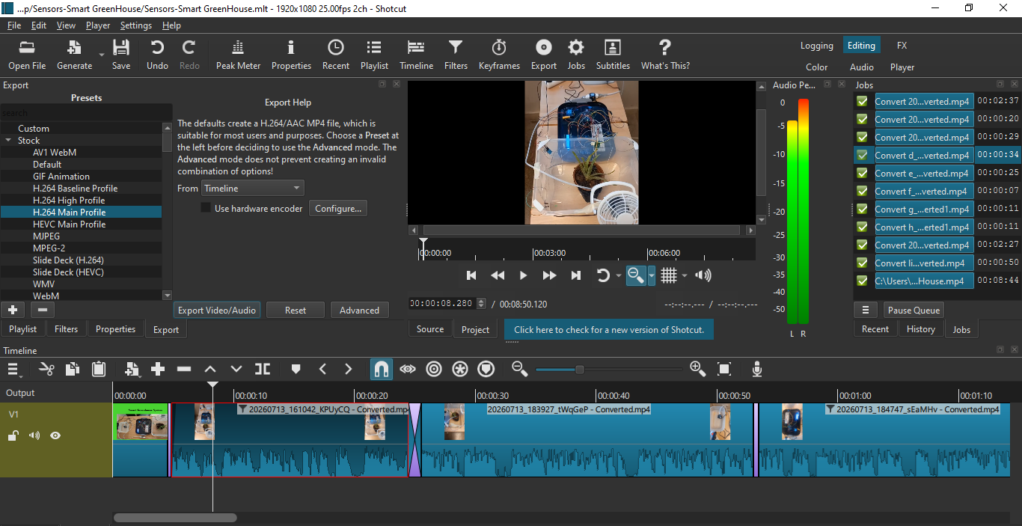
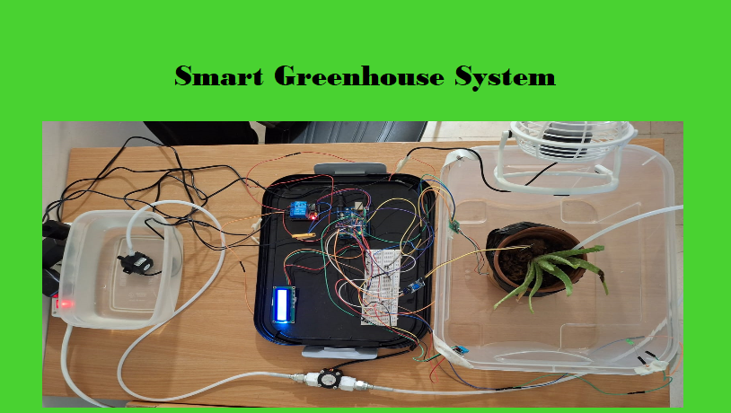

3. Personal Reflection
Working on this project taught me the importance of contributing across multiple aspects of a group project rather than only focusing on one task. Assisting with wiring and testing also helped me understand the practical challenges of integrating multiple sensors on a single microcontroller, especially around pin limitations and calibration issues we encountered with components like the HX711 load cell. Writing part of the engineering constraints section pushed me to think critically about the tradeoffs behind our design decisions — cost versus performance, and prototype limitations versus real-world deployment needs. Editing video and having to manage the load of information to show in one video showed me how hard this part is after I thought it was easy to do. I also learned how sensors work together and how Arduino wirings are not that hard as I thought. Overall, I learned that meaningful contribution in a team project isn't always about deep specialization in one area, but about staying engaged and reliable across the full lifecycle of the build.

